8.b) Experiment with different types of animations (fade, slide, etc.).
import 'package:flutter/material.dart';

void main() {
runApp(const MyApp());
}

/// Main app with animation type selector
class MyApp extends StatelessWidget {
const MyApp({super.key});

@override
Widget build(BuildContext context) {
return MaterialApp(
title: 'Flutter Animation Types Demo',
debugShowCheckedModeBanner: false,
home: const AnimationTypeDemo(),
);
}
}

enum AnimationType { fade, slide, scale }

class AnimationTypeDemo extends StatefulWidget {
const AnimationTypeDemo({super.key});

@override
State<AnimationTypeDemo> createState() => _AnimationTypeDemoState();
}

class _AnimationTypeDemoState extends State<AnimationTypeDemo> with SingleTickerProviderStateMixin {
late AnimationController _controller;

late Animation<double> _fadeAnimation;
late Animation<Offset> _slideAnimation;
late Animation<double> _scaleAnimation;

AnimationType _currentType = AnimationType.fade;

@override
void initState() {
super.initState();

_controller = AnimationController(
duration: const Duration(seconds: 2),
vsync: this,
);

_fadeAnimation = Tween<double>(begin: 0.0, end: 1.0).animate(
CurvedAnimation(parent: _controller, curve: Curves.easeInOut),
);

_slideAnimation = Tween<Offset>(begin: const Offset(-1, 0), end: Offset.zero).animate(
CurvedAnimation(parent: _controller, curve: Curves.easeInOut),
);

_scaleAnimation = Tween<double>(begin: 0.5, end: 1.0).animate(
CurvedAnimation(parent: _controller, curve: Curves.elasticOut),
);

_controller.forward();
}

@override
void dispose() {
_controller.dispose();
super.dispose();
}

void _changeAnimation(AnimationType type) {
setState(() {
_currentType = type;
_controller.reset();
_controller.forward();
});
}

Widget _buildAnimatedWidget() {
const child = FlutterLogo(size: 100);

switch (_currentType) {
case AnimationType.fade:
return FadeTransition(
opacity: _fadeAnimation,
child: child,
);

case AnimationType.slide:
return SlideTransition(
position: _slideAnimation,
child: child,
);

case AnimationType.scale:
return ScaleTransition(
scale: _scaleAnimation,
child: child,
);
}
}

@override
Widget build(BuildContext context) {
return Scaffold(
appBar: AppBar(
title: const Text('Fade, Slide & Scale Animations'),
centerTitle: true,
),
body: Column(
mainAxisAlignment: MainAxisAlignment.center,
children: [
Center(child: _buildAnimatedWidget()),
const SizedBox(height: 50),

Wrap(
spacing: 20,
children: [
ElevatedButton(
onPressed: () => _changeAnimation(AnimationType.fade),
child: const Text('Fade'),
style: ElevatedButton.styleFrom(
backgroundColor: _currentType == AnimationType.fade ? Colors.teal : null,
),
),
ElevatedButton(
onPressed: () => _changeAnimation(AnimationType.slide),
child: const Text('Slide'),
style: ElevatedButton.styleFrom(
backgroundColor: _currentType == AnimationType.slide ? Colors.teal : null,
),
),
ElevatedButton(
onPressed: () => _changeAnimation(AnimationType.scale),
child: const Text('Scale'),
style: ElevatedButton.styleFrom(
backgroundColor: _currentType == AnimationType.scale ? Colors.teal : null,
),
),
],
),
],
),
);
}
}

Output
Fade
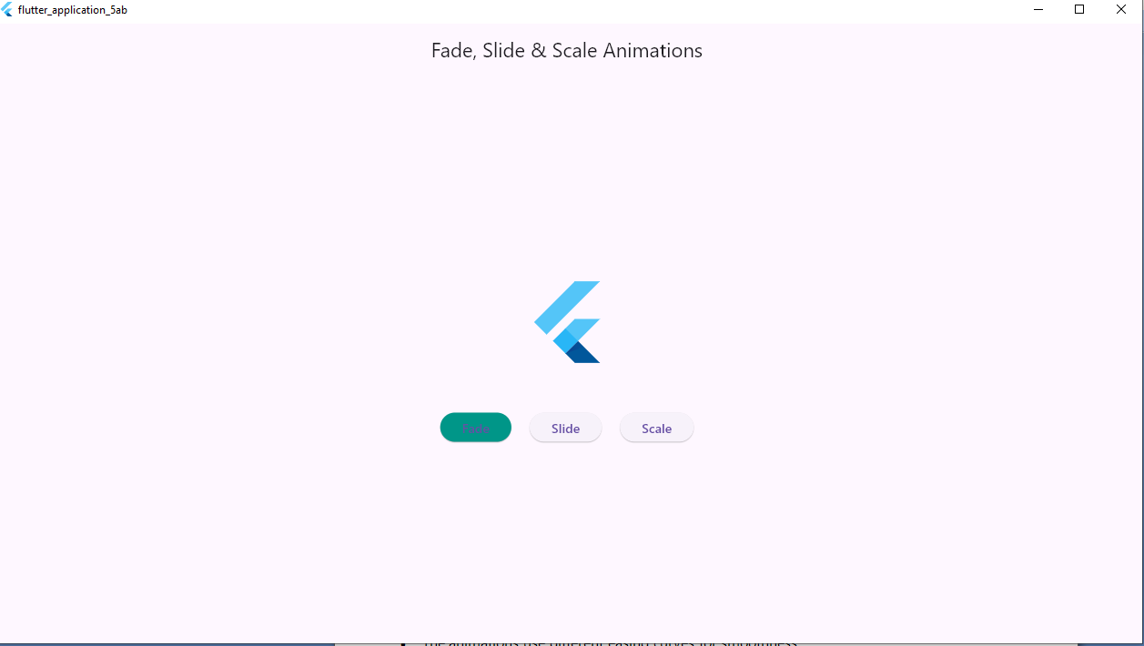
Slide
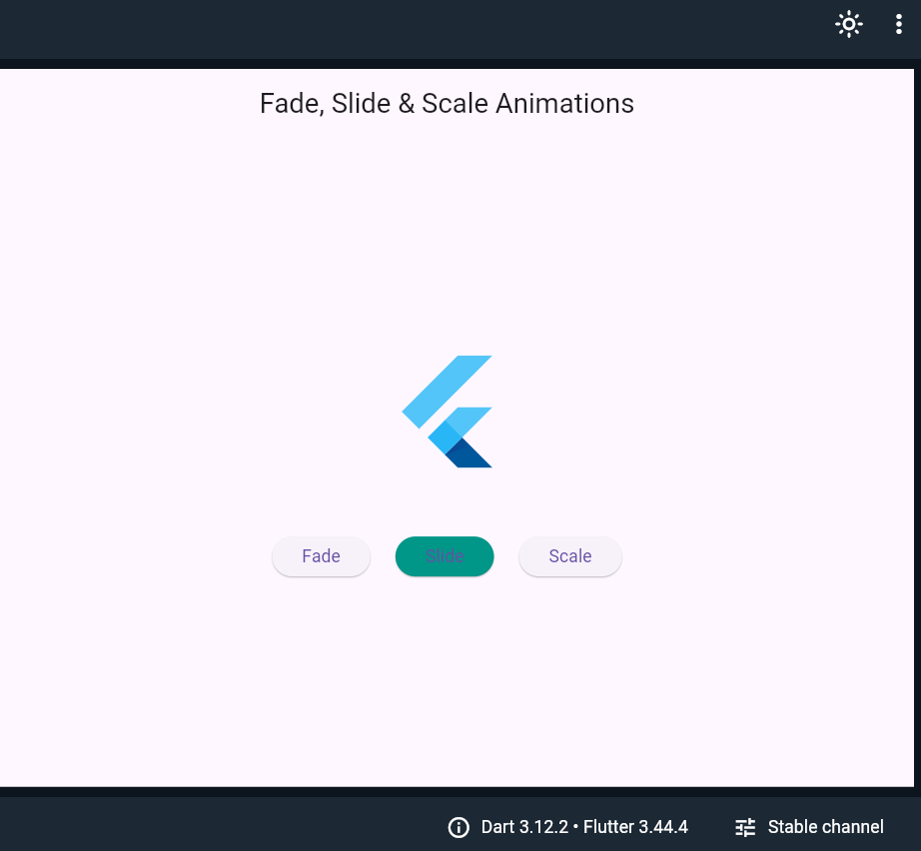
Scale
